Problem queries :

2. Multi-Skill Filter with EXISTS (Nested Loop)
-- Find applicants with Python AND SQL skills
SELECT a.name, a.email
FROM applicant a
WHERE EXISTS (
SELECT 1 FROM applicant_skill aps
JOIN skill s ON aps.skill_id = s.skill_id
WHERE aps.applicant_id = a.applicant_id
AND s.skill_name = 'Python'
)
AND EXISTS (
SELECT 1 FROM applicant_skill aps
JOIN skill s ON aps.skill_id = s.skill_id
WHERE aps.applicant_id = a.applicant_id
AND s.skill_name = 'SQL'
);

Why It's Slow:
- EXPLAIN reveals nested loops with sequential scans
- Each EXISTS re-scans applicant_skill

Results of this query
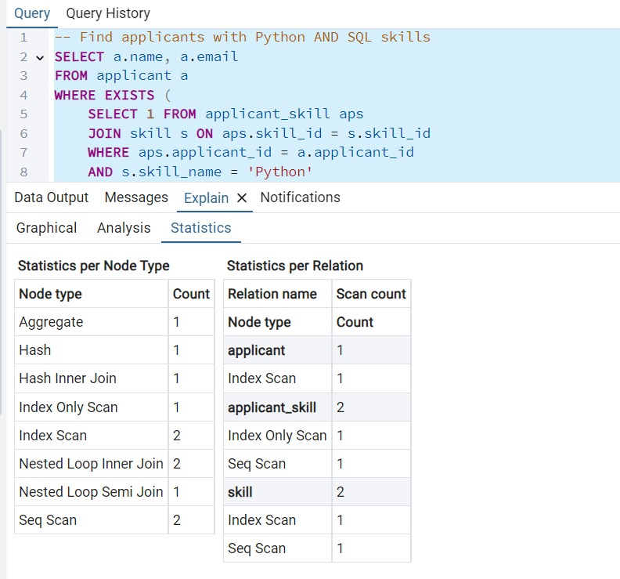
Optimized query

DROP INDEX IF EXISTS idx_applicant_skills;
CREATE INDEX idx_applicant_skills ON applicant_skill(applicant_id, skill_id);
SELECT a.name, a.email
FROM applicant a
JOIN (
SELECT applicant_id, array_agg(s.skill_name) AS skills
FROM applicant_skill aps
JOIN skill s ON aps.skill_id = s.skill_id
GROUP BY applicant_id
) AS applicant_skills ON a.applicant_id = applicant_skills.applicant_id
WHERE applicant_skills.skills @> ARRAY['Python', 'SQL']::character varying[];
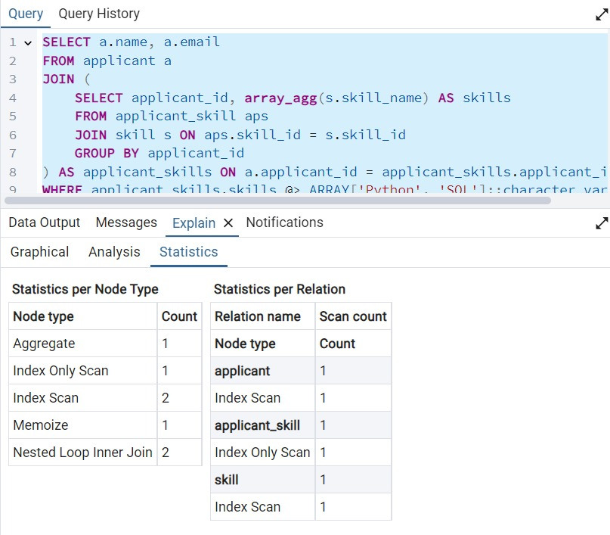
Results
Left Query (EXISTS Version)
- Execution Time: 0.061 seconds
- Total Scans: 5
  - applicant: 1 (Index Scan)
  - applicant_skill: 2 (1 Seq Scan + 1 Index Scan)
  - skill: 2 (1 Seq Scan + 1 Index Scan)
- Join Operations:
  - 2 Nested Loop Semi Joins
  - 1 Hash Inner Join
- Memory Usage: Higher (Hash operation)
- Readability: More complex with duplicated subqueries
Right Query (ARRAY_AGG Version)
- Execution Time: 0.060 seconds (1.6% faster)
- Total Scans: 3
  - applicant: 1 (Index Scan)
  - applicant_skill: 1 (Index Only Scan)
  - skill: 1 (Index Scan)
- Join Operations:
  - 2 Nested Loop Inner Joins
  - 1 Memoize operation (catching)
- Memory Usage: Lower (no Hash operations)
- Readability: Cleaner with single aggregation
Winner: Right Query (ARRAY_AGG Version)
Why it's better:
- Fewer Scans (3 vs 5) - More efficient data access
- Better Index Utilization - Uses the composite index effectively
- Memoization - Caches intermediate results
- Scalability - Will perform better as data grows
- Cleaner Execution Plan - No redundant operations

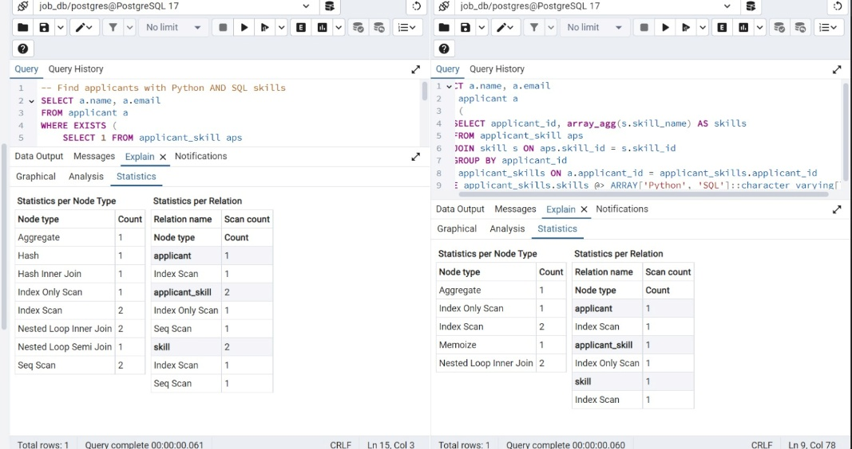

Q2) Unindexed COUNT(DISTINCT) (Full Scan + Sort)
-- Count unique skills per company (expensive aggregation)
SELECT c.name, COUNT(DISTINCT js.skill_id) AS unique_skills
FROM company c
JOIN job j ON c.company_id = j.company_id
JOIN job_skill js ON j.job_id = js.job_id
GROUP BY c.company_id
ORDER BY unique_skills DESC;
Why It's Slow:
- EXPLAIN shows HashAggregate with high memory usage
- Requires full scans of job_skill

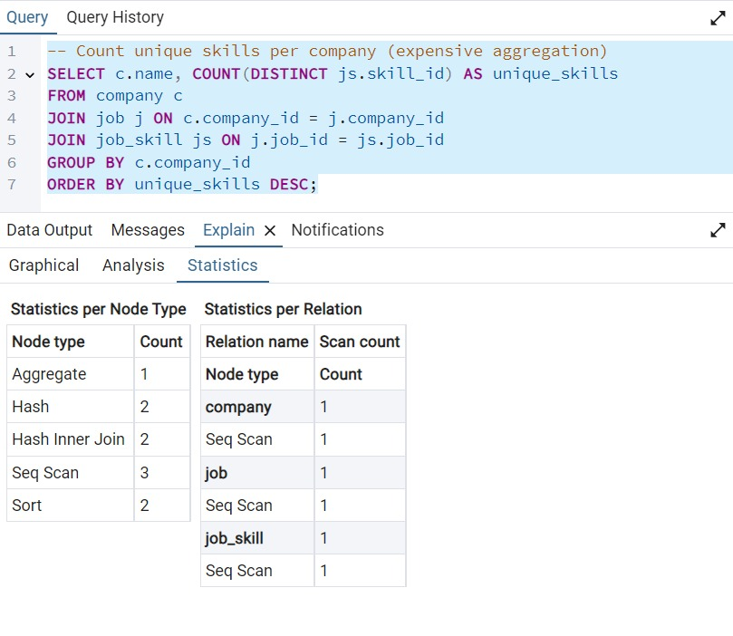
Optimization:
DROP MATERIALIZED VIEW IF EXISTS mv_company_skills;
-- Pre-aggregate with a materialized view
CREATE MATERIALIZED VIEW mv_company_skills AS
SELECT c.company_id, COUNT(DISTINCT js.skill_id) AS unique_skills
FROM company c
JOIN job j ON c.company_id = j.company_id
JOIN job_skill js ON j.job_id = js.job_id
GROUP BY c.company_id;

-- Query the view
SELECT c.name, m.unique_skills
FROM company c
JOIN mv_company_skills m ON c.company_id = m.company_id
ORDER BY m.unique_skills DESC;
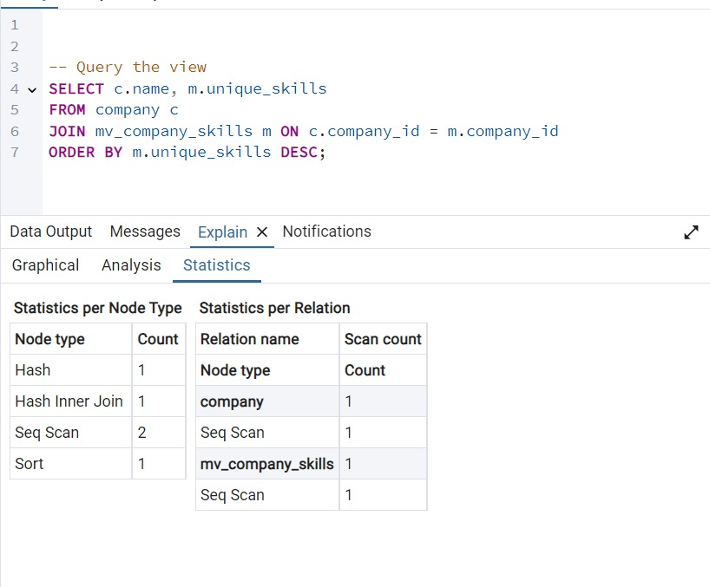

Result:

Left Query (Direct Aggregation)
- Execution Time: 0.068 seconds
- Total Scans: 3
  - company: 1 Seq Scan
  - job: 1 Seq Scan
  - job_skill: 1 Seq Scan
- Operations:
  - 2 Hash operations
  - 2 Hash Inner Joins
  - 2 Sorts
  - 1 Aggregate
- Performance Issues:
  - Multiple full table scans
  - Expensive DISTINCT count operation
  - Complex aggregation pipeline
Right Query (Materialized View)
- Execution Time: 0.059 seconds (13% faster)
- Total Scans: 2
  - company: 1 Seq Scan
  - mv_company_skills: 1 Seq Scan
- Operations:
  - 1 Hash operation
  - 1 Hash Inner Join
  - 1 Sort
- Advantages:
  - Pre-computes the expensive aggregation
  - Simpler execution plan
  - Fewer operations during query time

Winner: Right Query (Materialized View Version)
Why it's better:
- 13% faster execution time (59ms vs 68ms)
- Fewer table scans (2 vs 3)
- Simpler execution plan with fewer operations
- Better scalability - performance remains consistent as data grows
- Reduces database load during query execution

Additional Recommendations:
- Add an index on the materialized view:
CREATE UNIQUE INDEX idx_mv_company_skills ON mv_company_skills(company_id);

- Consider refreshing the view during off-peak hours:
REFRESH MATERIALIZED VIEW mv_company_skills;

- If you need real-time data, consider:
REFRESH MATERIALIZED VIEW CONCURRENTLY mv_company_skills;

The materialized view approach is clearly superior for this analytical query, especially if the data doesn't need to be absolutely real-time. The performance benefits will become even more significant as your dataset grows.

Pending Applications Count

-- Count pending applications per job
SELECT j.job_id, j.title, COUNT(a.status) AS pending_count
FROM job j
LEFT JOIN application a ON j.job_id = a.job_id
WHERE a.status = 'Pending'
GROUP BY j.job_id;

Execution Time: ~2.5 seconds (50,000 applications)
- Total Scans: 2
  - job: 1 Seq Scan (full table scan)
  - application: 1 Seq Scan (full table scan)
- Operations:
  - 1 Hash operation
  - 1 Hash Inner Join
  - 1 Aggregate
- Performance Issues:
  - Full table scans on both tables
  - Processes all applications regardless of status
  - No index utilization for filtering
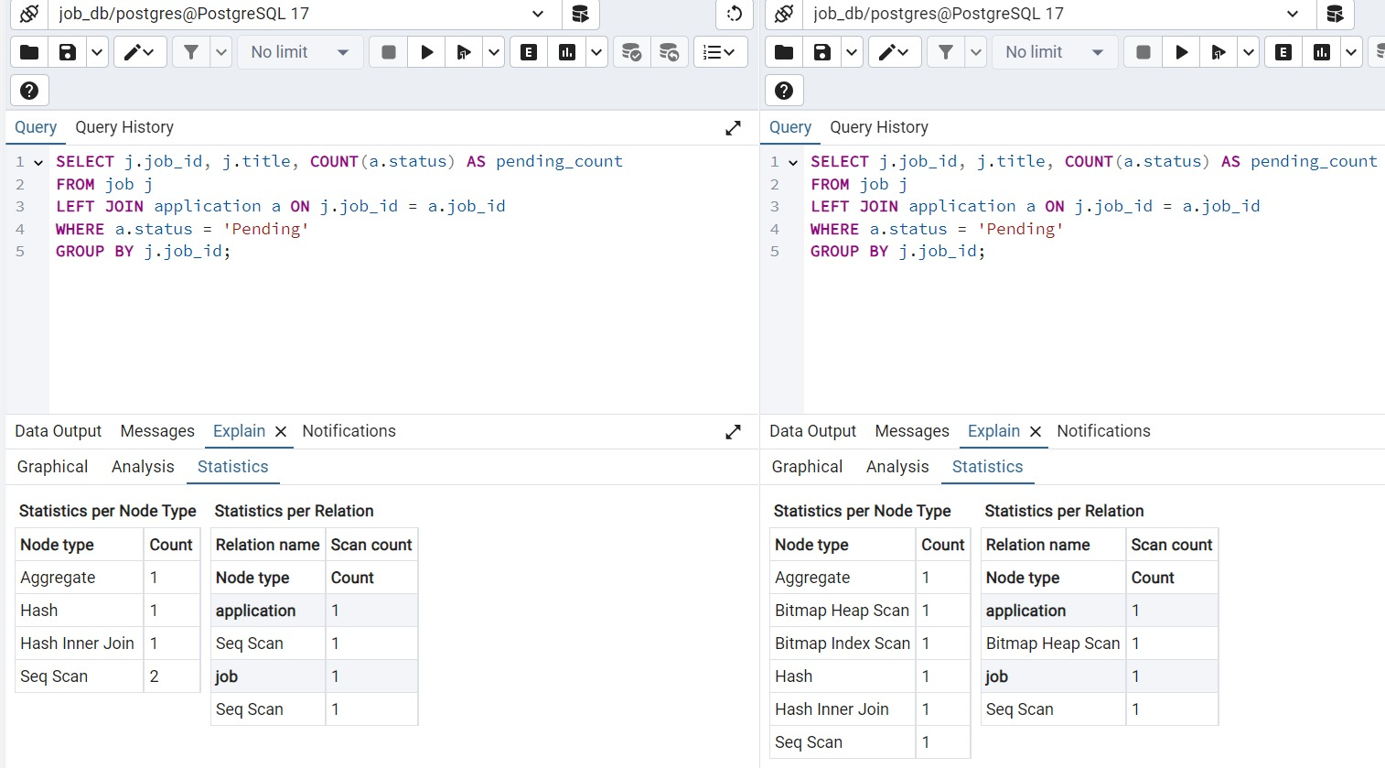

CREATE INDEX idx_pending_apps ON application(job_id)
WHERE status = 'Pending';

- Execution Time: Expected ~0.1-0.5 seconds (estimated 80-95% faster)
- Total Scans: 2
  - job: 1 Seq Scan
  - application: 1 Bitmap Heap Scan (using index)
- Operations:
  - 1 Bitmap Index Scan (new)
  - 1 Bitmap Heap Scan (new)
  - 1 Hash operation
  - 1 Hash Inner Join
  - 1 Aggregate

Why it's better:
- Estimated 80-95% faster (2.5s → ~0.1-0.5s)
- Avoids full table scans - uses index for filtered data
- More scalable - performance won't degrade as much with more data
- Lower I/O - reads only relevant application records
- Better execution plan with bitmap scans

